Vulnerability Assessment and Penetration Testing of “Riipen” Web Application.

Ankan Garg

*Department of Computer Science New York Institute of Technology*

Vancouver, Canada NYIT ID: 1299560

[agar](mailto:agarg07@nyit.edu)[g07@nyit.edu](mailto:g07@nyit.edu)

Felix Majemite

*Department of Computer Science New York Institute of Technology*

Vancouver, Canada NYIT ID: 1275854

[fmajemit@nyit.edu](mailto:fmajemit@nyit.edu)

Taiwo Mebude

*Department of Computer Science New York Institute of Technology*

Vancouver, Canada NYIT ID:1305695

[tmebude@nyit.edu](mailto:tmebude@nyit.edu)

*Abstract*— This report presents the current progressive development, success, and failure of vulnerability assessment and Penetration testing of Riipen. Riipen is a web application that provides services to bridge the gap between the Company and the University regarding availability and accessibility to enterprise projects. This website helps both parties, such as employers, Educators, and Students, to have continuous opportunities to work together with everyone accomplished.

*Keywords— Riipen, WebApp, OWASP Top10, ZAP, recon, Attacks, Vulnerabilities, remediations, Tools, nmap, reverse lookup, Kali Linux, Scripts, Cyber Killchain*

**Introduction:** This report presents a comprehensive web penetration test conducted on the web application of Riipen, a leading experiential learning platform. Riipen distinguishes itself by providing educational institutions and students with a wide range of remote-friendly opportunities, bridging the gap between educators and employers[1](https://riipen.com/).

The primary objective of this web penetration test was to identify potential vulnerabilities in Riipen's web application and propose remediation strategies to enhance its security. This is crucial as web application vulnerabilities, such as SQL Injection, Cross-Site Scripting (XSS), and Cross-Site Request Forgery (CSRF), can be exploited by attackers to compromise the application.

**Problem statement:** The RIIPEN web application could be susceptible to various logical and technical vulnerabilities. Technical vulnerabilities such as SQL injection, cross-site scripting, broken authentication, and security misconfiguration are potential threats that could compromise the web application's security. These vulnerabilities are significant as they can undermine the security of web applications. The causes of these vulnerabilities can range from poorprogramming practices to outdated systems.

# PROJECT OBJECTIVES:

The central objective is integrating penetration testing practices within an educational framework. This encompasses acquiring knowledge, implementing practical exercises, and iteratively enhancing ethical hacking skills. The overarching goal is to systematically dissect attack patterns, identify vulnerabilities, and develop effective mitigation strategies through hands-on experience and learning,

fostering a robust understanding of cybersecurity in an educational context.

# REVIEW OF RELATED WORK

In every project, related work is usually integral; we shall extensively use the MITRE framework, considered the Bible for pen testers. We shall utilize various pentest reports, online best practices, and other related frameworks to solidify our endeavors.

# METHODOLOGY AND DESCRIPTIONS

The primary aim of this project is to conduct a comprehensive penetration test on a web application system, encompassing five pivotal tasks: reconnaissance, enumeration, exploitation, post-exploitation/maintaining access, and covering tracks.

These objectives are

**Reconnaissance**: Thoroughly gather information and intelligence about the target web application to understand its structure, architecture, and potential vulnerabilities.

**Enumeration**: Systematically identify any exposed services, applications, or weaknesses within the web application, aiming to catalog possible entry points.

**Exploitation**: Actively assess and exploit identified vulnerabilities to ascertain the extent of potential security breaches, emphasizing ethical and controlled exploitation.

**Post-Exploitation/Maintaining Access:** After gaining initial access, establish mechanisms to maintain a persistent presence within the system, simulating how a malicious actor might persist within a compromised environment.

**Covering Tracks**: Implement countermeasures and techniques to obfuscate penetration testing activities, mimicking an attacker's efforts to evade detection.

Others:

**Pre-Engagement**: Permission seeking or request is essential to ethical hacking practices. Personnel from Riipen with authority gave the go-ahead for the possibility of forms of pentesting done and recorded in this paper.

# VI. SUB-TECHNIQUES IN VARIOUS METHODOLOGY

**Reconnaissance concepts**

Spidering: a concept of crawling through a website and following all the links on the site, creating a working construct of the web application’s functionalities[1].

Forced Browsing: though similar to crawling, more importantly, it finds hidden connected interfaces. This helps to build a profile of how the web application is put together[1].

1. Directory Transversal: this goes beyond the web application construction information gathering and towards the host machine the WebApp is running on[1].
2. Banner grabbing: collecting information on the web server and framework[1].
3. Server Fingerprinting: using tools that help scan Host details with a narrower focus, such as Nmap properties[1].
4. Documentation look-up: this is a good way to identify APIs and know if their elements are vulnerable[1].
5. Vulnerability Database: these accounts of real-life documented vulnerabilities are available for look-up and cross-reference analysis, such as Common Vulnerability and Exposure, Exploit Database, and Shodan[1].

# Reconnaissance tools Used and relationship to concepts:

Numerous tools are available and used during this project; some can accomplish multiple concepts due to the improvement of technology and their automated ability. Furthermore, these tools can conduct reconnaissance in passive and active states[2].

Passive state refers to the ability of a tool to scan/ analyze the target without interactions such as crawling. On the other hand, an Active state requires interactions, for example, Nmap port scanning.We employed various techniques and tools to actively and passively conduct reconnaissance on the isolated, restricted website,as outlined below: some of these tools figures can be found in Appendix B for illustration.

* 1. Host: The `host` command serves the purpose of querying Domain Name System (DNS) servers to perform domain name-to-IP address or IP address-to-domain name resolution.
  2. Nslookup: "Nslookup" is a shortened form of "name server lookup," a utility that facilitates the querying of Domain Name System (DNS) services. This tool is commonly employed through a command line interface (CLI) to retrieve domain names, retrieve IP address mapping information, and perform DNS record lookups.
  3. Wappalyzer: Wappalyzer is a technology profiling tool that provides insights into the technological stack powering websites. It can identify the Content Management System (CMS), frameworks, e-commerce platforms, JavaScript libraries, and other components used to construct a website.

Fig 1: Wapalyzer demonstrates web technologies utilized by Riipen.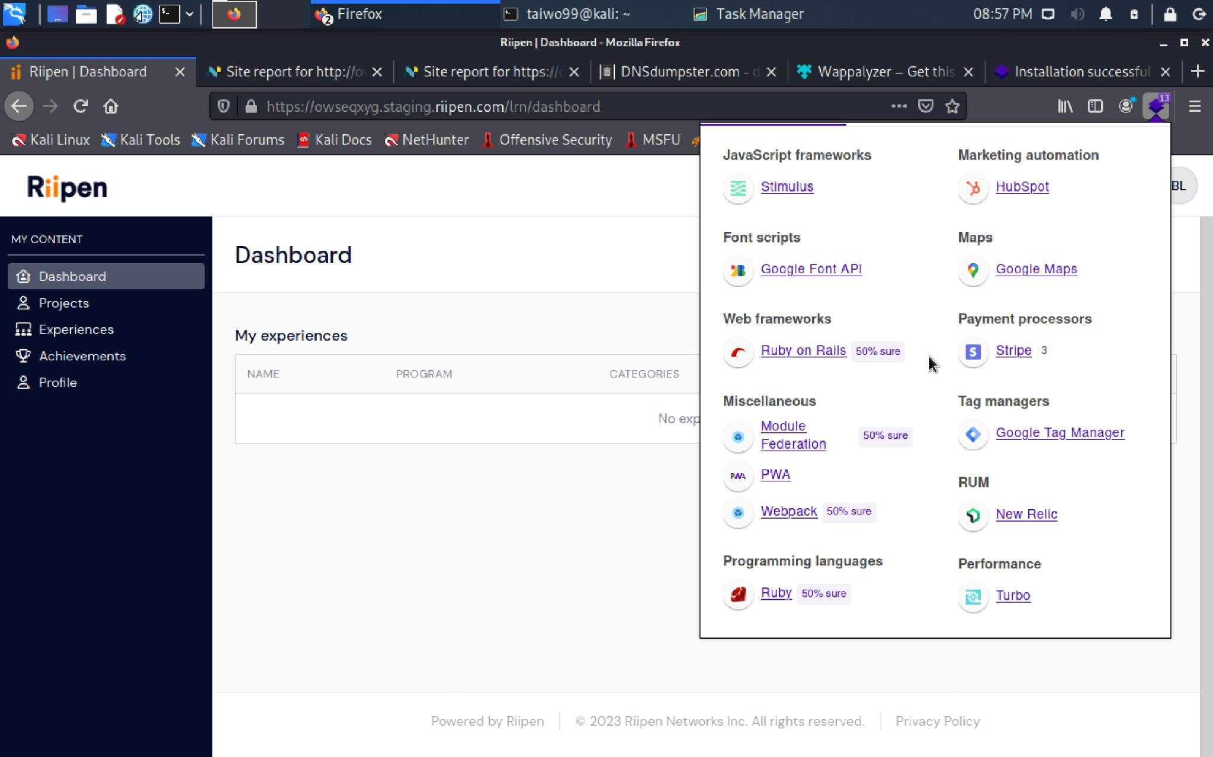

* 1. Nikto is an open-source command-line vulnerability scanning tool that conducts thorough assessments of web servers to detect potentially hazardous files, Common Gateway Interfaces (CGIs), obsolete server software, and other security-related issues. Fig 5. Depict vulnerability scanning result carried by Nikto

Fig 2. Depict vulnerability scanning result carried by Nikto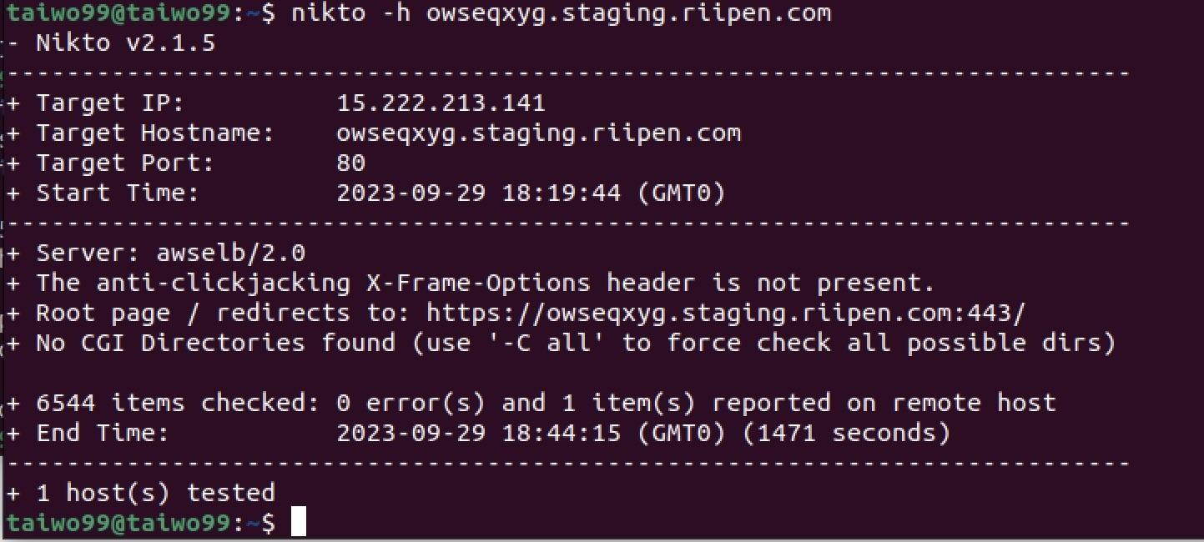

* 1. Wafw00f: Wafw00f is an open-source tool specifically developed for identifying and fingerprinting Web Application Firewalls (WAFs).

Fig 3.Showing recon result for a WAF scan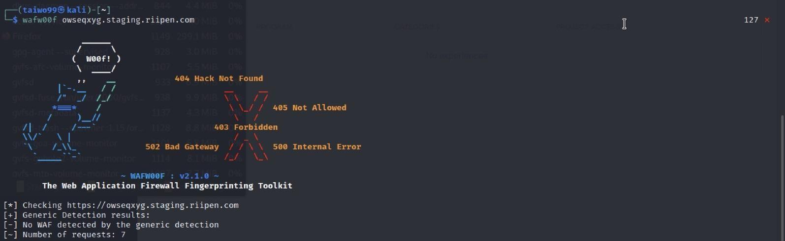

* 1. Nessus: a creation by Tenable, is a robust platform meticulously crafted to scan for security vulnerabilities across an extensive spectrum of targets, including devices, applications, operating systems, cloud services, and various network resources.
  2. Sniper: This is an automated scanner utilized within the context of a penetration test. Its purpose is to enumerate and scan for vulnerabilities systematically.
  3. OWASP ZAP

This tool was created by the Open Worldwide Application Security Project (OWASP), an open-source tool for vulnerability assessment of web applications using URLs and IP addresses. This tool does an in-depth analysis using almost all concepts mentioned in this paper, such as spidering, forced browsing, directory transversal, and server fingerprinting, just to name a few. Proxy properties can sit between the browser and the user and are used to create HTTP requests and receive responses.

Owasp Zap Scan Result of Riipen

1. Initial login page scan:

Using passive scanning properties such as crawling

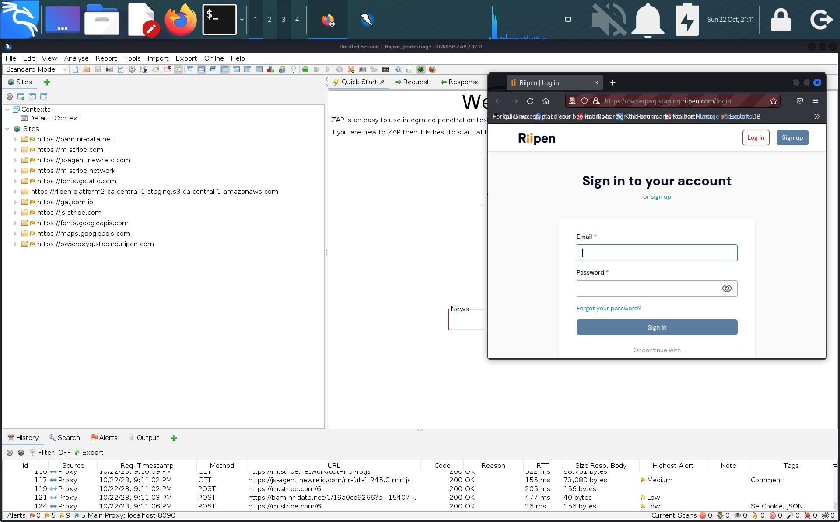

Fig 4. Showing login page scan info.

1. Potential alerts and flags detected in these scans:

Owasp Zap is an automated vulnerability assessment tool that is highly effective in exhausting all possible links using all forms of libraries inside of it. It also color codes alert flags according to the level of risk:

Red Alert: high level of risk found in a web application.

Orange Alert: medium level of risk found after scans.

Yellow Alert: low level of risk of risk

Blue Alert: without the three main levels, an information alert creates more clarity.

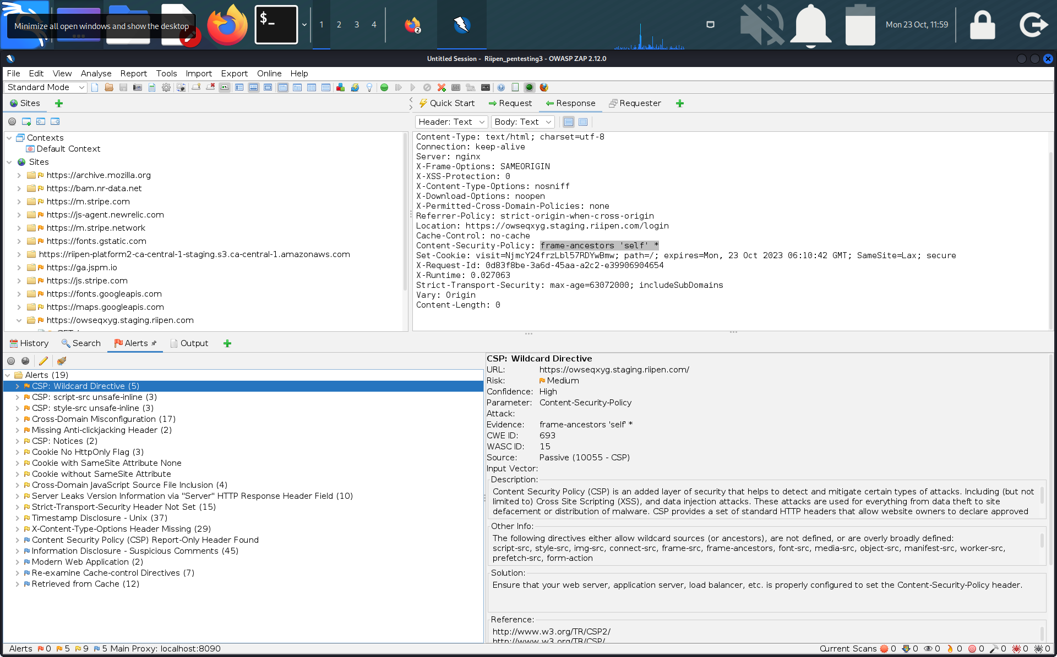

Fig 5. Showing Alert including flags and all the attributes.

In the end, Owasp Zap completely scanned every inch of the Riipen website in search for vulnerabilities that were tangible but found none. There is a HTML report documenting the record of the scans done by owasp zap as a pentesting tool. This report will be submitted and posted in the repository.

**Enumeration/ findings**

In pentesting, a close relationship exists between reconnaissance and enumerations, which refers to the next step after recon. Documentation of notable properties of Riipen as the target website after recon scans are as follows:

**SSL/TLS vulnerability:** The web URL is not SSL vulnerable. It is not based on TLS1.1 and TLS1.2, which are vulnerable versions. The overall ranking of the certificate looks good.

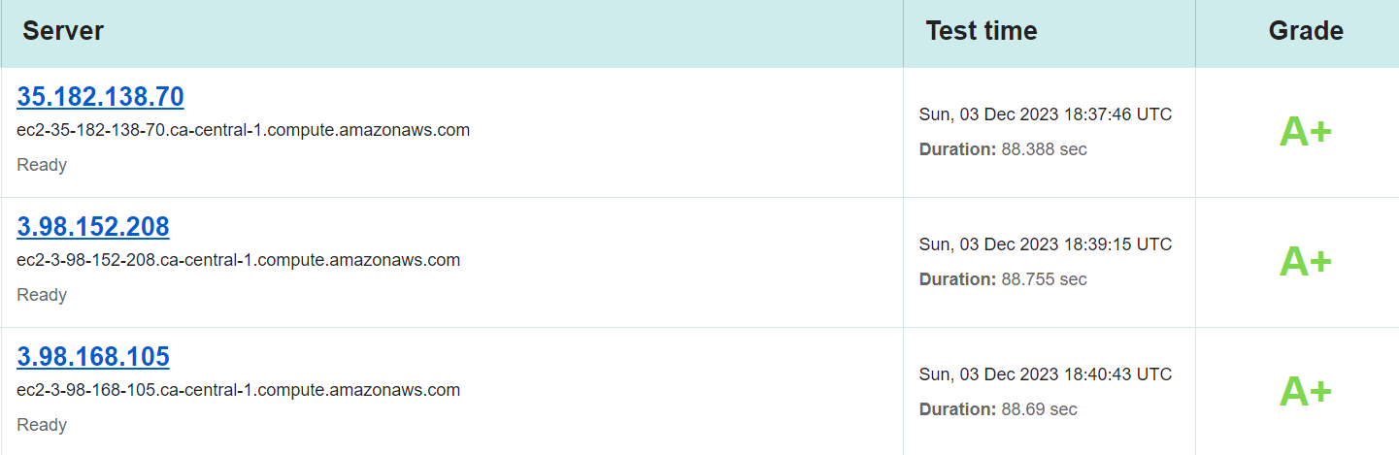

Fig 6. SSL/TLS check

**EMAIL/SPAM Spoofing:** Email spoofing is a technique used by cybercriminals to send emails that appear to come from a known, trusted source to trick the recipient. It exploits the fact that most email protocols do not authenticate the sender's address, allowing it to be easily forged.

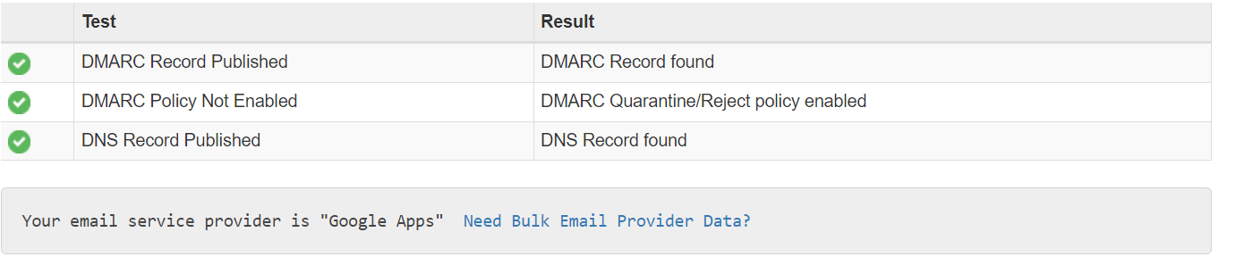

Fig 7. EMAIL Protocol checking

**Result** : The protocols DKIM, DMARC, and SPF are all set. Hence, it's not vulnerable to email spoofing or spamming attacks.

**Clickjacking:** Clickjacking is a cyber-attack where a malicious website tricks a user into clicking on something different from what they think they are clicking. The attacker overlays transparent buttons or other interface elements over a legitimate website in a hidden iframe.

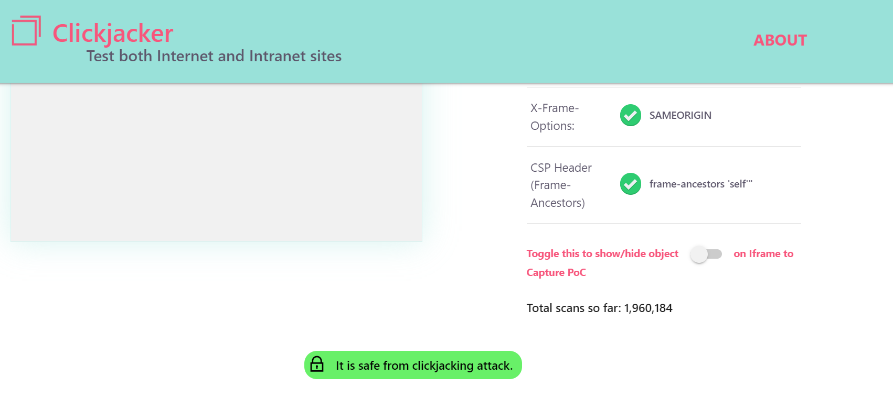

Fig 8. Clickjacking attack

**Result**: Upon performing header analysis, it's clear that the website is not prone to clickjacking attacks.

**Broken link Hijacking:** Broken link hijacking is an attack where cybercriminals exploit expired or inactive external links on websites to carry out malicious activities like defacement, phishing, and impersonation. Attackers hijack the broken links by registering expired domains or replacing passive resources.

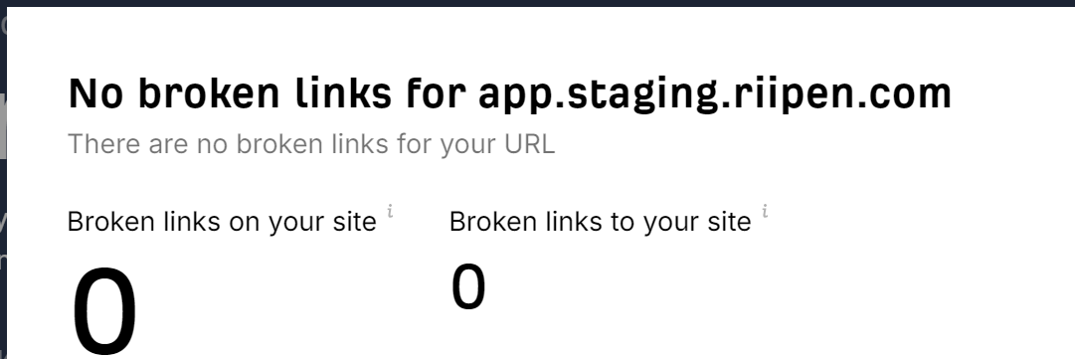

Fig 9. Broken link check

**Result** : The web URL is free from any dead or unclaimed links. Hence, it is safe from this attack.

**Security Headers:**

Security headers are HTTP response headers that instruct browsers on how to handle web content securely. Implementing headers like Content-Security-Policy, X-Frame-Options, and Strict-Transport-Security can mitigate common attacks like cross-site scripting, clickjacking, and man-in-the-middle attacks. Security headers restrict dangerous functionality in browsers and limit the attack surface for malicious actors. Using proper security headers is a simple yet effective way to strengthen the security posture of a website. They are an essential line of defense that reduces application vulnerabilities and protects users' data and privacy.

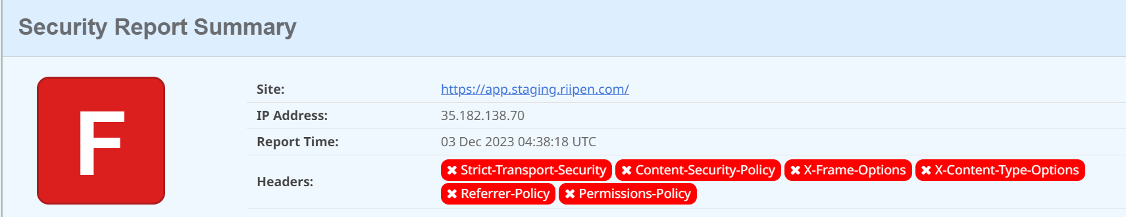

Fig 10. Security headers validation

**Results:** As per the data shared, the web URL is missing a few security headers. which are as follows:

Strict-transport-security, content-security-policy, X-Frame-options, X-Content-Type-options, Referrer-policy and Permission- policy. explanations are found in the appendices C section.

**DNS spoofing** The classic DNS poisoning attack is to send a DNS server a query that you think will cause the server to do a recursive lookup and then blast it with spoofed responses for that lookup before the real ones can arrive. The server will cache the first response, which will be yours.

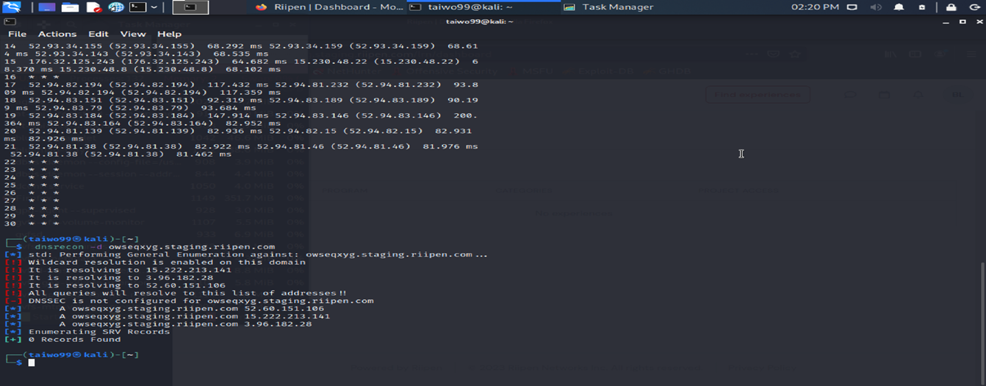

Fig 11. DNSSEC check

**Result**: It can be observed from our enumeration that DNSSEC is not enabled. This should be enabled to prevent such kinds of attacks and reduce the overall attack surface.

**Reverse IP domain check:** This was performed on the various IP addresses where the website is hosted to understand if the domain is also getting shared with other customers.

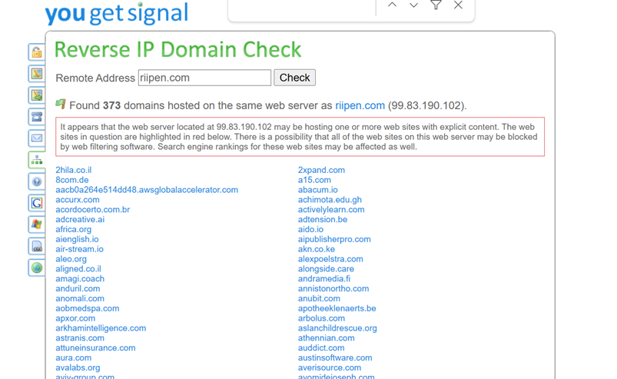

Fig 12. Reverse lookup IP

**Result**: It was noticed that the production website is sharing the hosting space with other real-world applications which is a risk. Seems like all the applications listed above are hosted on the same AWS instance.

**Identity and Access Management misconfig:** Authentication and authorization are important mechanisms at any organization . It enforces “Principle of Least Privilege” and ensures the right user has right access in an organization .

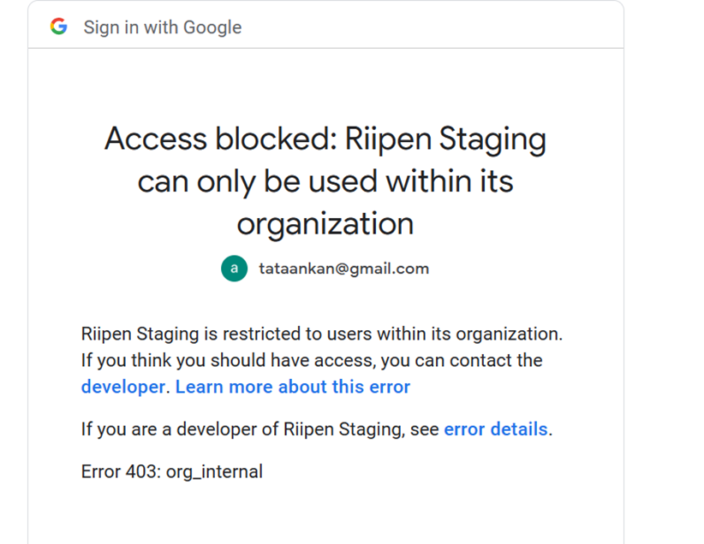

Fig 13. Identity check

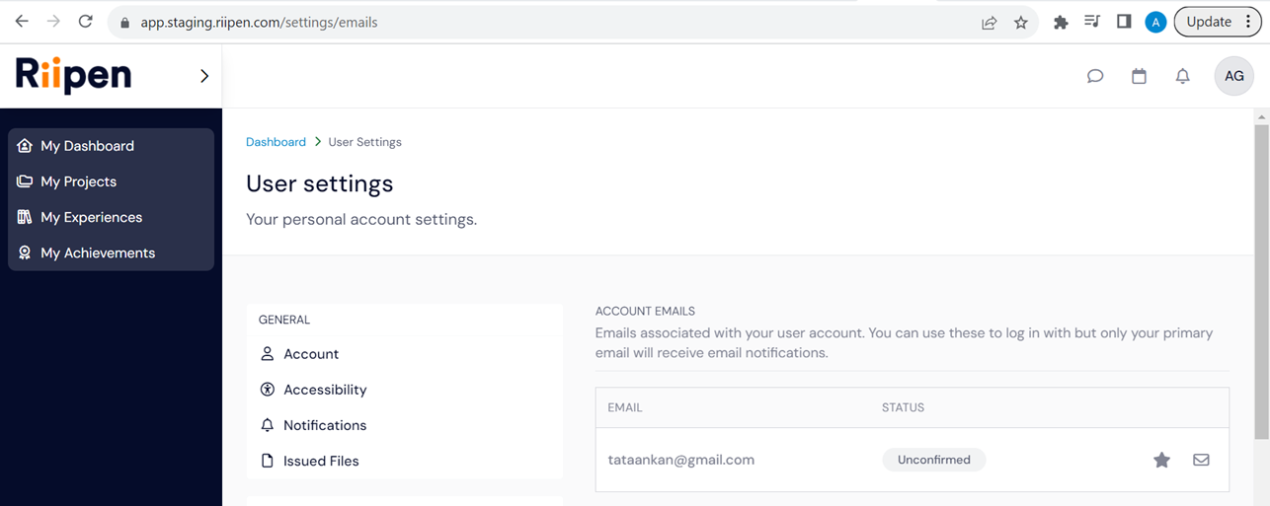

Fig 14. Identity management issue

**Result** : As can be seen from the screenshots , in-staging environmen;t only .riipen.com accounts were allowed to have access but since it was misconfigured we were able to login via gmail.com as well .

**Pre-account takeover :**  As part of initial reconnaissance , we tried exploiting the create account field to create various accounts .

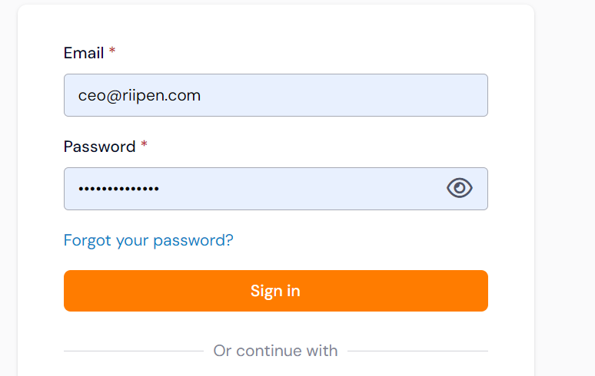

Fig 15. Pre-account of CEO/CTO

**Result** : We were able to create an account using ceo@riipen.com and [cto@riipen.com](mailto:cto@riipen.com) successfully . The same vulnerability has been informed to customer and they are working on the same .

**Session not expire after change of password :** Its a vulnerability where a user is not logged out from the session even if the password is changed for the account .

**Steps to reproduce and results -** The application is vulnerable to this attack . and steps followed are listed below :

- You need to login with same id in two browsers

- Attacker browser - firefox

- Victim browser - chrome

- You can change the password in chrome and go back to firefox

- Update first name or any information in firefox browser

- If the information is updated or the session is still live .

**Exploitation Trails**

After conducting reconnaissance and enumeration, three targeted attacks were executed based on the findings. These included a website directory traversal attack, a login bypass using SQLmap, and API fuzzing. The purpose was to identify and address vulnerabilities related to unauthorized access and potential weaknesses in the login system and application programming interface.

* **Website Directory Traversal Attack**: A Web Directory Traversal attack involves an attacker exploiting a vulnerability in a website's server to gain unauthorized access to restricted files and directories. This is achieved by manipulating the URL with special characters, allowing the attacker to access files and directories not intended for public access.
* To execute the Web Directory Traversal attack, we employed a tool named **dotdotpwn**. This tool serves as a versatile and intelligent fuzzer.

Designed to identify traversal directory vulnerabilities in various software, including HTTP/FTP/TFTP servers and web platforms such as CMSs, ERPs, and Blogs. It enables systematic testing for directory traversal vulnerabilities, enhancing the attack's efficiency.

**Figures 15 & 16** illustrate the outcomes of conducting fuzzing on the Ripen website to identify potential vulnerabilities. The results include the output of malicious special characters that can be utilized to manipulate the website, making it susceptible to a web directory traversal attack. These findings highlight potential weaknesses that should be addressed to enhance the website's security. Following the active fuzzing of the website, a minor timeout was experienced. However, further analysis will determine whether this was a successful denial of service attack or a potential hoax.

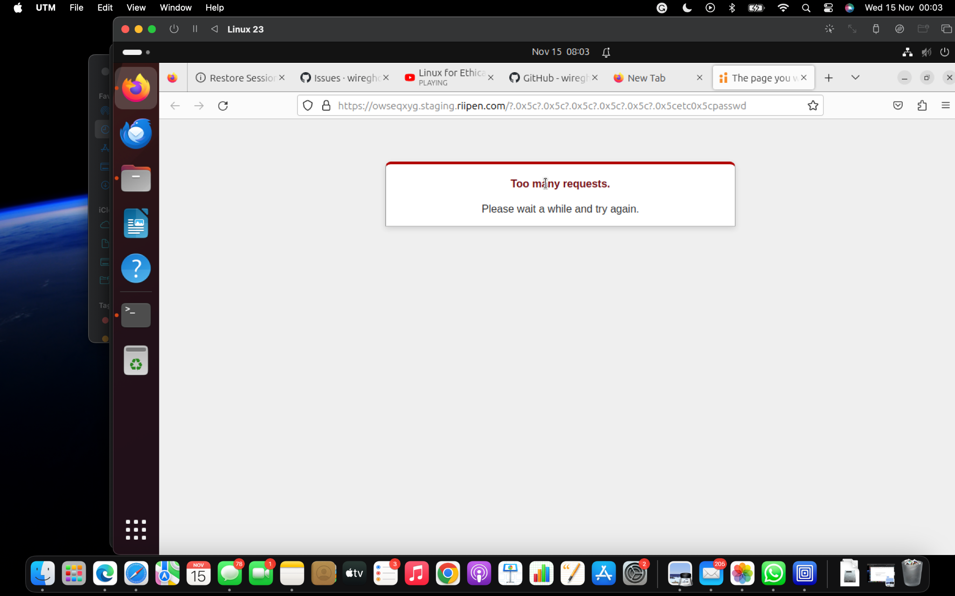

Fig 17. The image indicates a URL timeout, suggesting that the website was inaccessible or took too long to respond during the testing.

**Further Analysis:** After testing the Ripen URL with the potentially harmful characters identified by dotdotpwn in a web browser, it was observed that most URLs could not be accessed. This indicates that the website has some protection against the web directory traversal attack. all images are found in appendix B according to the figure numbers.

**Fig 18.** illustrates the website results after attempting to load most of the potentially vulnerable URLs.

**Fig 19.** This picture demonstrates that at least one of the URLs was successfully loaded, suggesting a potential vulnerability.

**Fig 20.** The image depicts a successful login attempt to the

URL, resulting in a "page not found" error.

**Fig 21.** In the security testing of the website, Burp Suite was used for scanning, and a directory traversal attack technique called Double URL encoding was employed to bypass security mechanisms and potentially retrieve sensitive information. Despite the attempt, no sensitive information was successfully obtained, indicating that the website may have effective security measures.

**SQL Injection**

SQL injection is a code injection technique aimed at data-driven applications. In this attack, the goal is to bypass the login page of the Riipen website by injecting malicious SQL codes. The intent is to manipulate the application's database through the login form, potentially gaining unauthorized access.

To execute the attack, we utilize SQLmap, an open-source penetration testing tool designed to automate the detection and exploitation of SQL injection vulnerabilities. The URL is fed into SQLmap, which employs various SQL injection techniques, including Blind SQL Injection (such as Time-Based Blind SQLi and Out-of-Band SQLi), to generate a payload capable of circumventing the login system.

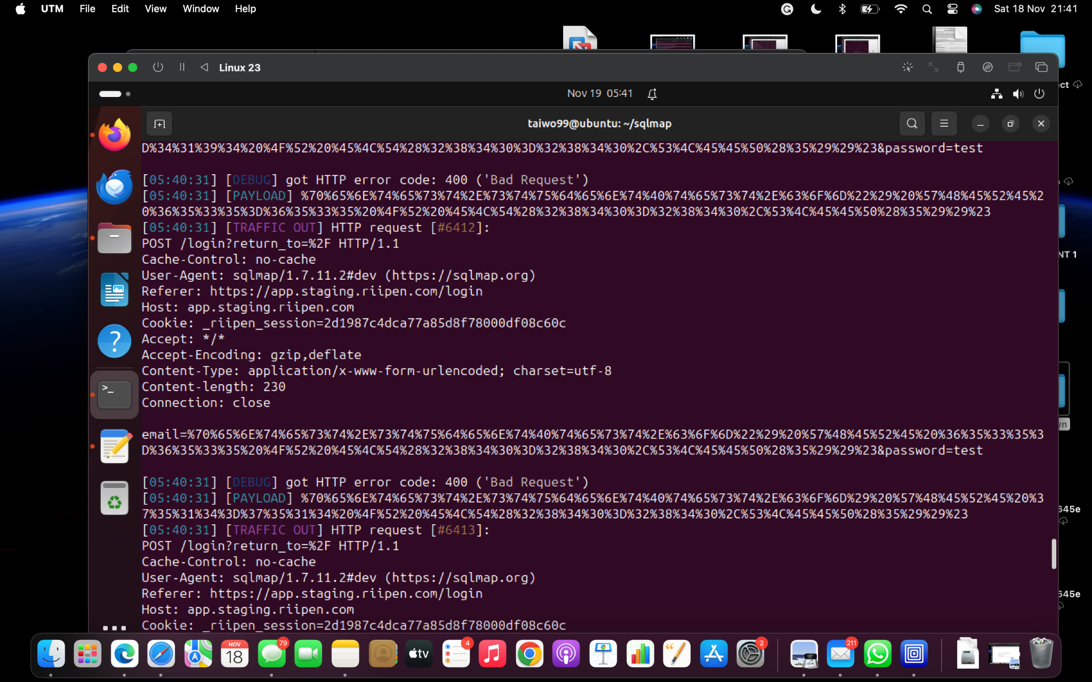

Fig 22: The image indicates an HTTP error 400 after injecting SQL payloads into the Ripen website. An HTTP 400 error typically signifies a Bad Request, suggesting that the server could not properly understand or process the SQL injection payloads. This outcome may indicate that the website has security measures to detect and prevent such attacks, making it resistant to the SQL injection attempt.

Further analysis and testing are essential to understand the website's robustness against security threats.

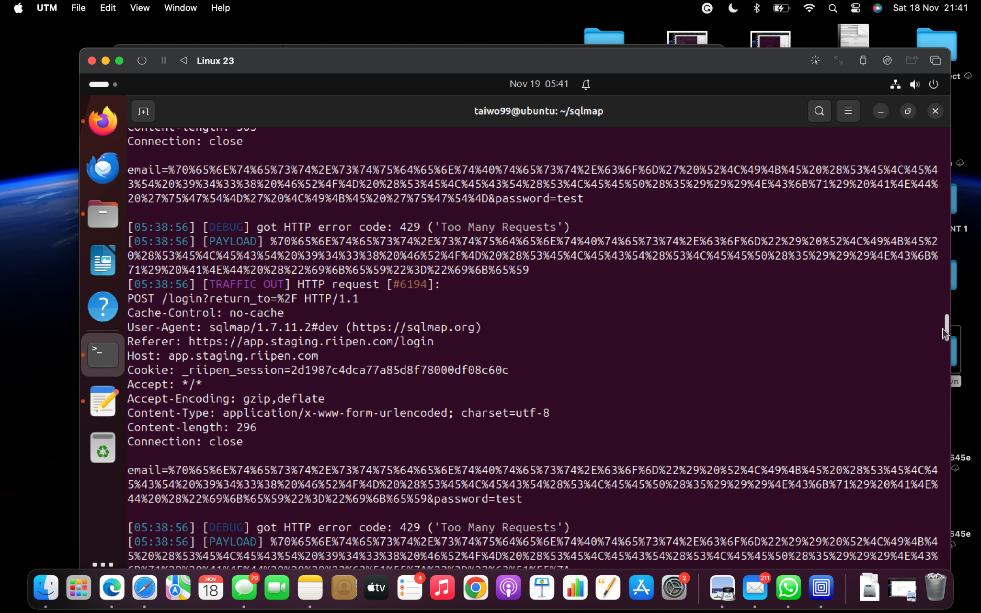

Fig 23: ​​The image indicates an HTTP error 429, which typically signifies a "Too Many Requests" status. This error suggests that the web server has received too many requests from the client in a given amount of time. Injecting SQL payloads into the Ripen website might be a result of the server detecting unusual or excessive activity, potentially in response to the SQL injection attempts.

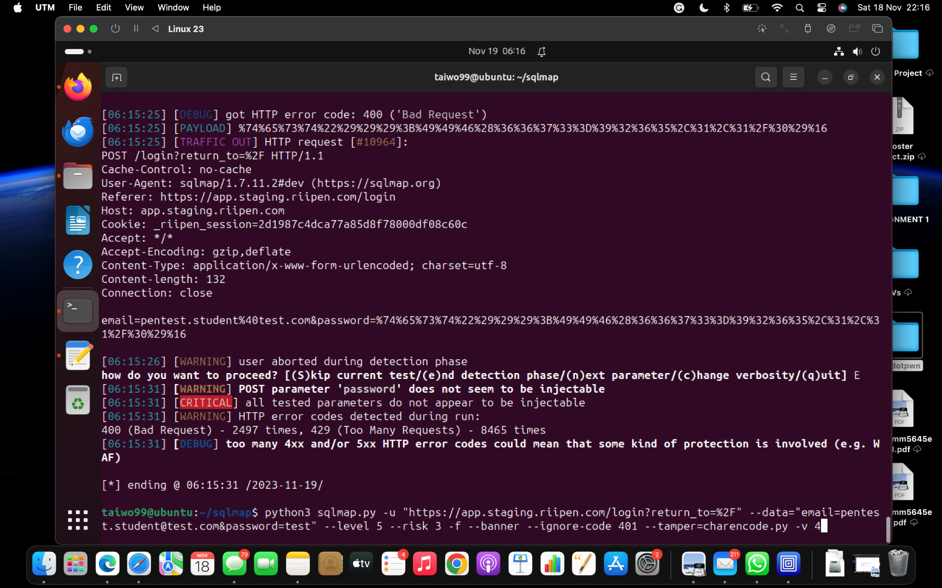

Fig 24: After injecting over 10,000 SQL injections, SQLmap observed that all parameters were marked non-injectable. This outcome suggests the presence of a firewall or other security measures that effectively blocked the SQL injection attempts.

**Conclusion and Future plans**

Riipen Vulnerability assessment and penetration testing was performed to the best of the knowledge of all participants both through learning curves and already acquired knowledge. In the end three mains process of the methodology from the framework was carried out; i.e. Reconnaissance, enumeration/findings and exploitation trials. Future plans of this project entails carrying out proper Api scans as at the current point in the project it was a challenge . Furthermore, the limitation of open source tools should be surpassed for more effective scans; that operable vulnerabilities could be found and mitigated.

Progress Status and Milestones

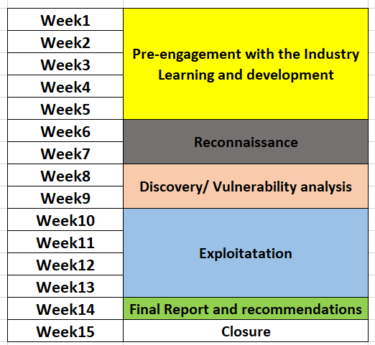

**References**

1. Cyber Technical Knowledge.“Web Application Penetration Testing Tutorial. ” YouTube.com.[https://www.youtube.com/watch?](https://www.youtube.com/watch?v=gqMZx5H_Om0&t=7210s) [v=gqMZx5H_Om0&t=7210s](https://www.youtube.com/watch?v=gqMZx5H_Om0&t=7210s) (accessed Sept. 14, 2023).
2. HackerSploit.“Red Team Reconnaissance Techniques.”youtube.com.[https://www.youtub](https://www.youtube.com/watch?v=BWaGnsRirtU) [e.com/watch?v=BWaGnsRirtU](https://www.youtube.com/watch?v=BWaGnsRirtU) (accessed Oct. 2, 2023).
3. C. M. J. Aileen and G. Bacudio, "AN OVERVIEW OF PENETRATION TESTING," *International Journal of Network Security & Its Applications (IJNSA)*.
4. V. S. KUMAR, "Ethical Hacking and Penetration Testing Strategies," *International Journal of Emerging Technology in Computer Science & Electronics (IJETCSE)*, vol. 11
5. P. Ami and A. Hasan, "Seven Phrase Penetration Testing Model," *International Journal of Computer Applications*, vol. 59.
6. K. and K. K. Ankita Gupta, "Vulnerability Assessment and Penetration Testing", *International Journal of Engineering Trends and Technology.*

**Appendix A; Github**

This is just an opportunity to state certain plans and documents. All commands used this project word be documented and submitted with the report and also to the repository.

repository-link: <https://github.com/FelixUfuoma/Final-project>

**Appendix B: Images**

Images illustrated in this Appendix section are mentioned according to usage.

1. **kali embedded**:

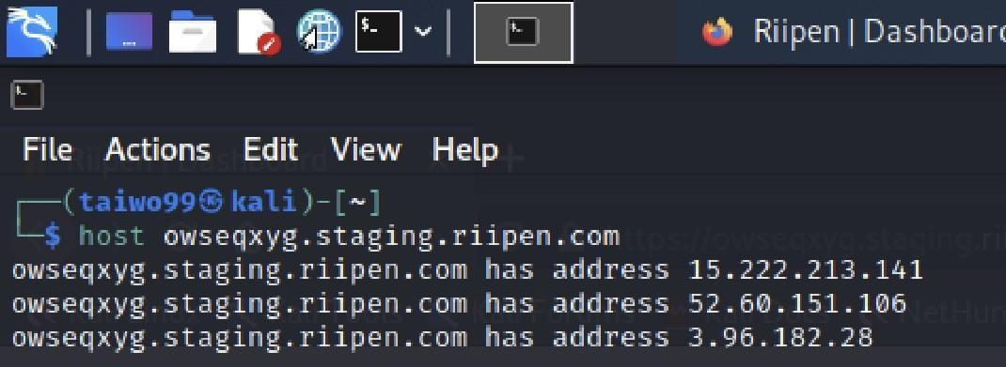

Host

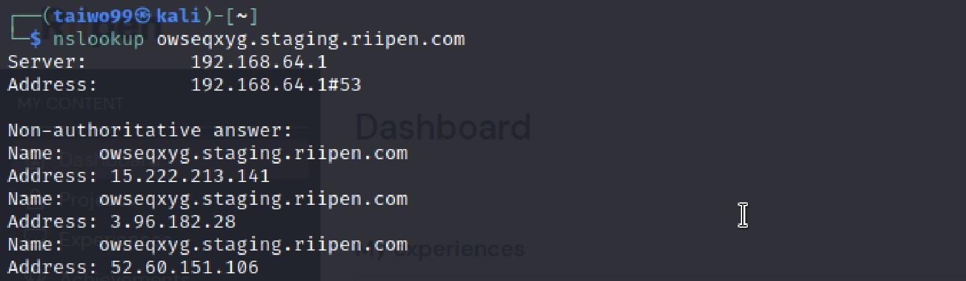

Nslookup

1. Automated tool:

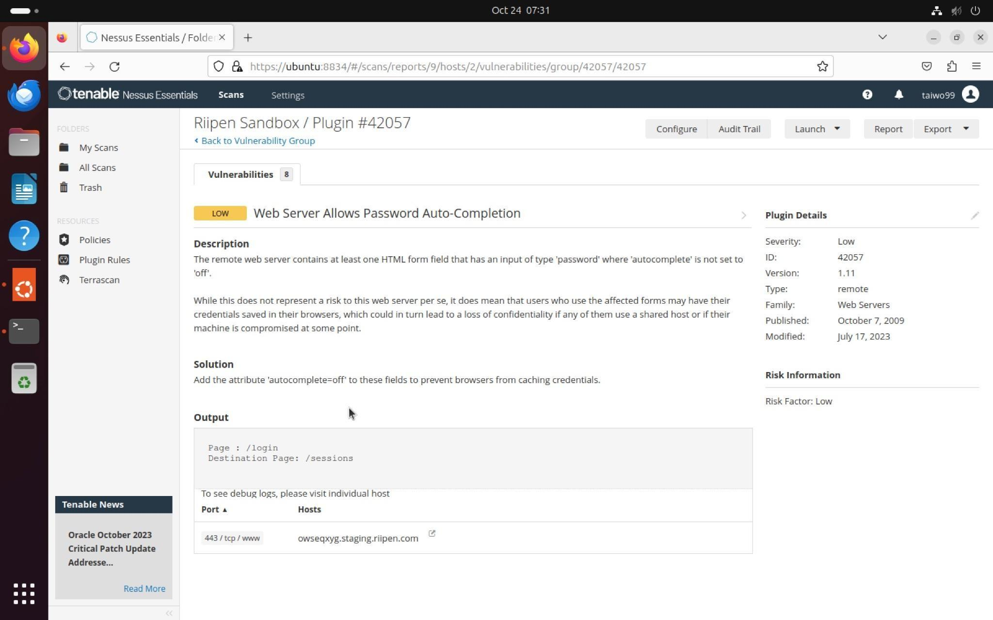

Nessus

1. Number Images: exploitation Trails

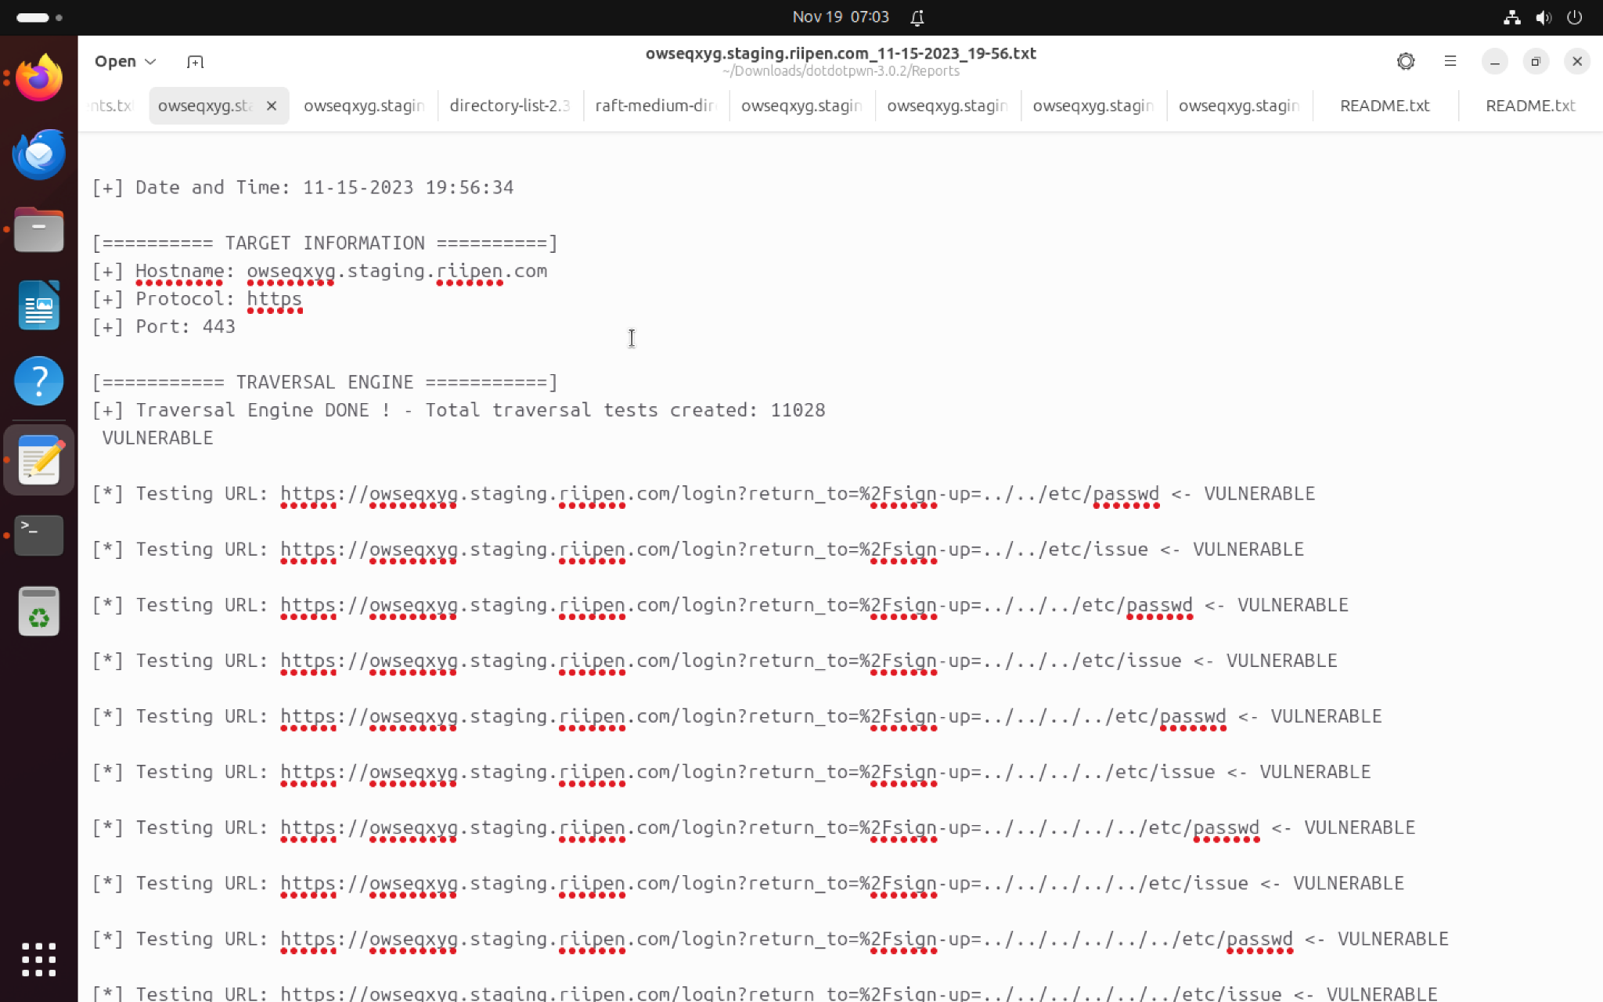

Fig 15.

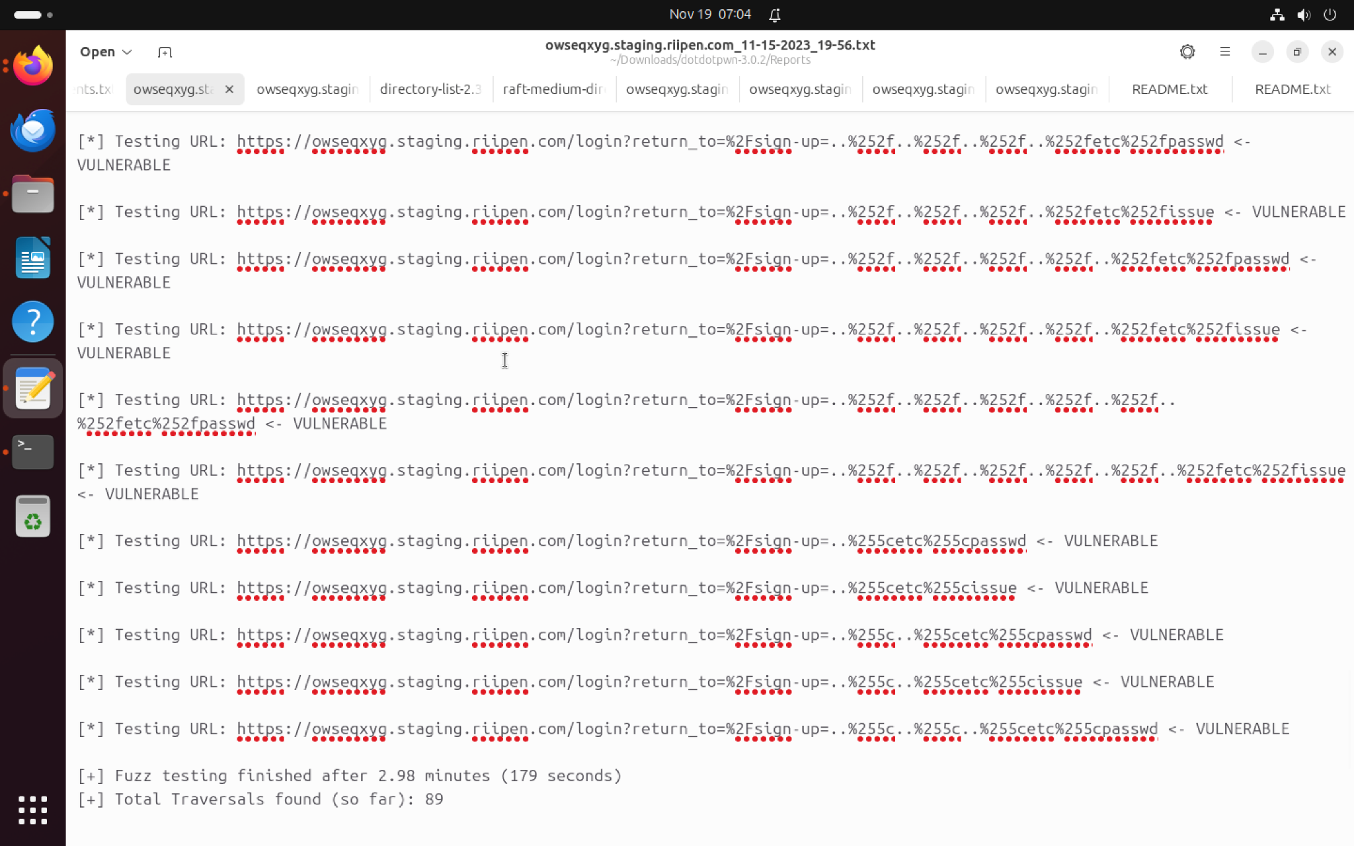

Fig 16.

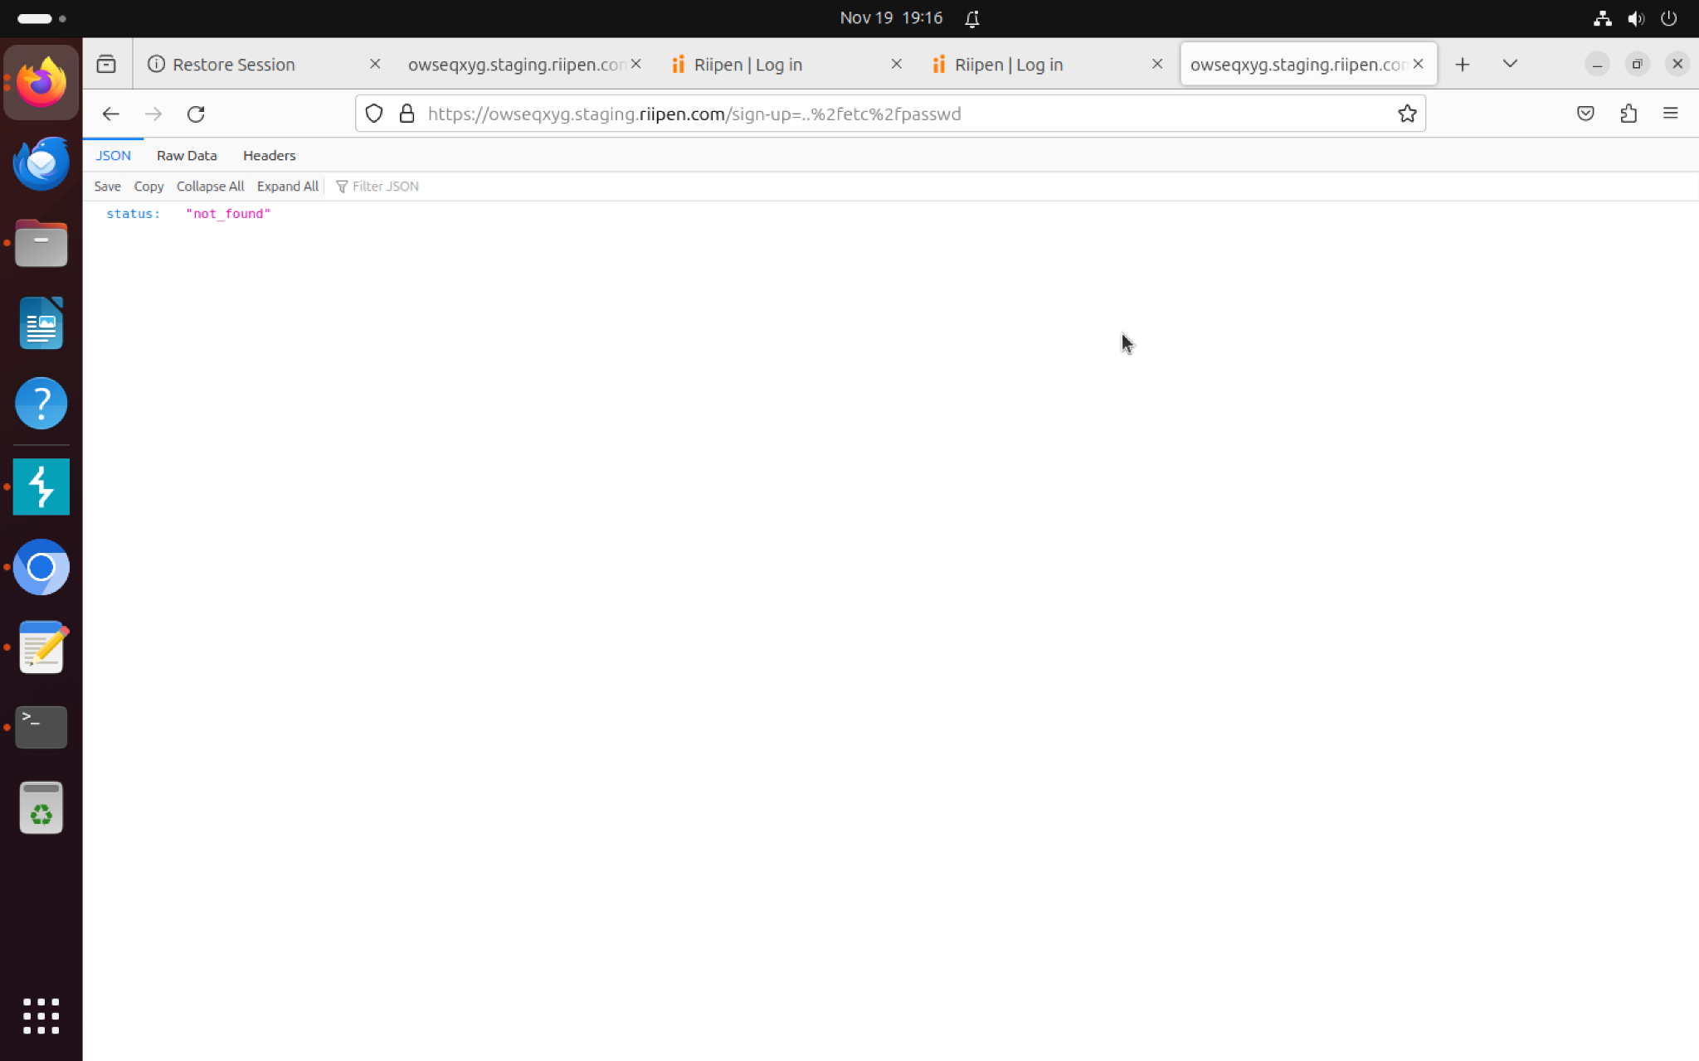

fig 18.

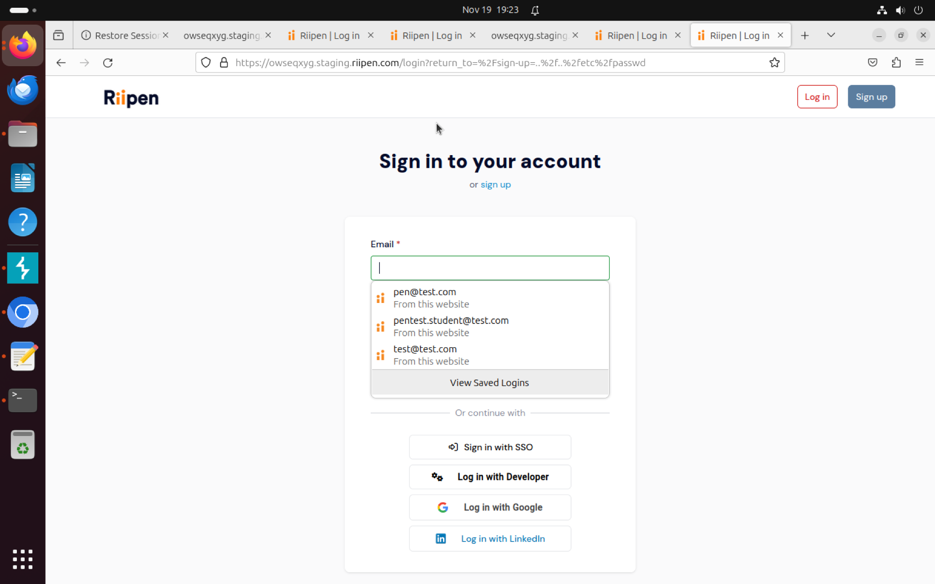

Fig 19.

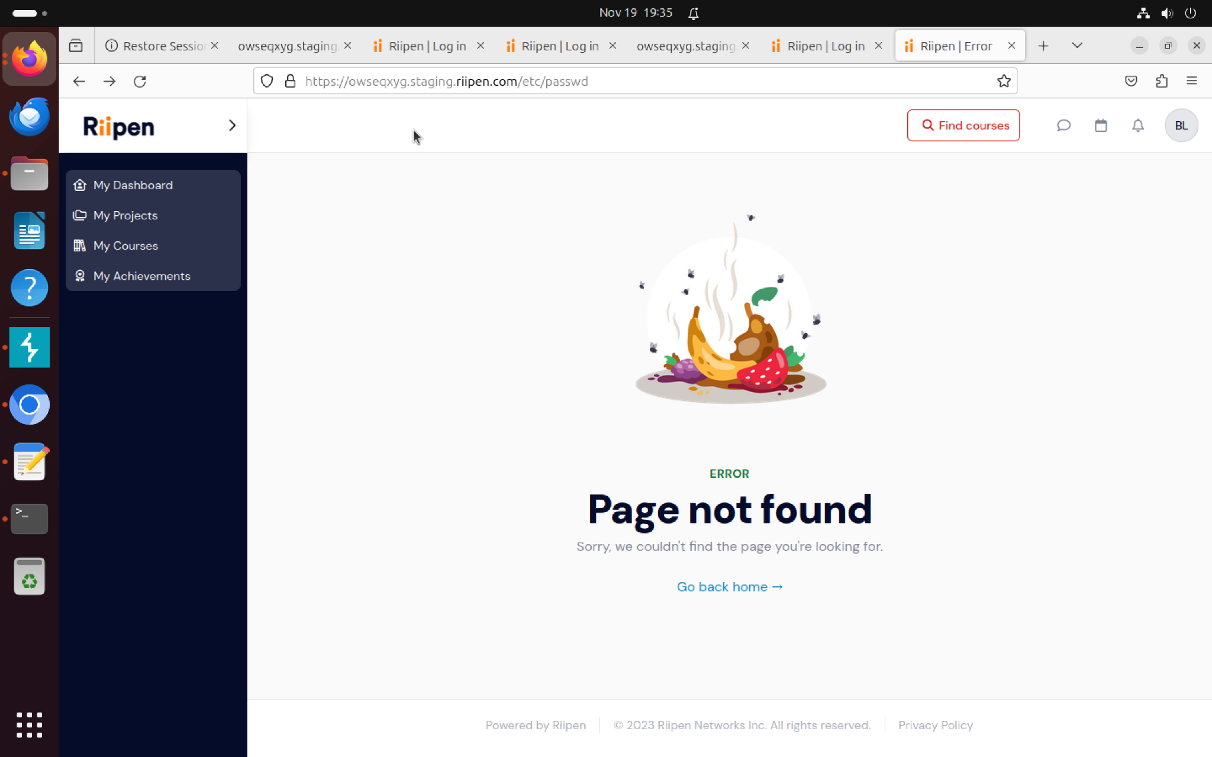

Fig 20.

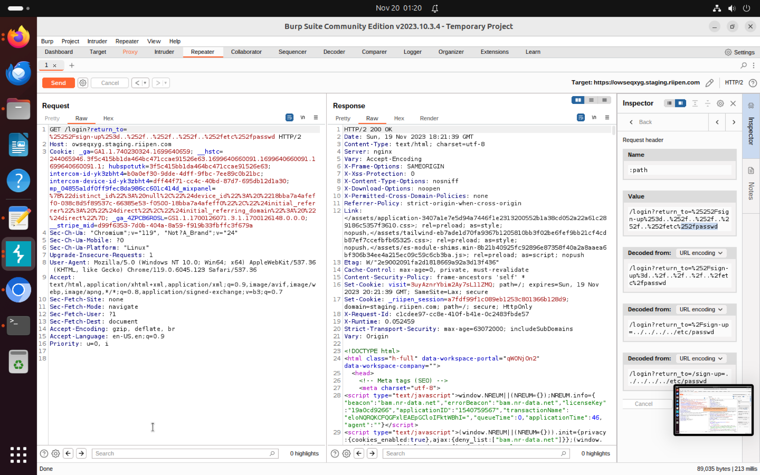  
Fig 21.

**Appendices C: index**

* Strict-Transport-SecurityHTTP Strict Transport Security is an excellent feature to support your site. It strengthens the implementation of TLS by getting the User Agent to enforce HTTPS. Recommended value "Strict-Transport-Security: max-age=31536000; includeSubDomains".
* Content-Security-Policy: Content Security Policy is an effective measure to protect your site from XSS attacks. By whitelisting sources of approved content, you can prevent the browser from loading malicious assets.
* X-Frame-Options: X-Frame-Options tells the browser whether you want to allow your site to be framed or not. By preventing a browser from framing your site, you can defend against attacks like clickjacking. Recommended value "X-Frame-Options: SAMEORIGIN"
* X-Content-Type-Options: X-Content-Type-Options stops a browser from trying to MIME-sniff the content type and forces it to stick with the declared content type. The only valid value for this header is "X-Content-Type-Options: nosniff".
* Referrer-Policy: Referrer Policy is a new header that allows a site to control how much information the browser includes with navigations away from a document and should be set by all sites.
* Permissions-Policy: Permissions Policy is a new header that allows a site to control which features and APIs can be used in the browser.

**Appendix D: enumeration and findings**

**Load Balancer and Reverse proxy:** We discovered that the application is hosted on three web servers and is supported by a load balancer configuration.

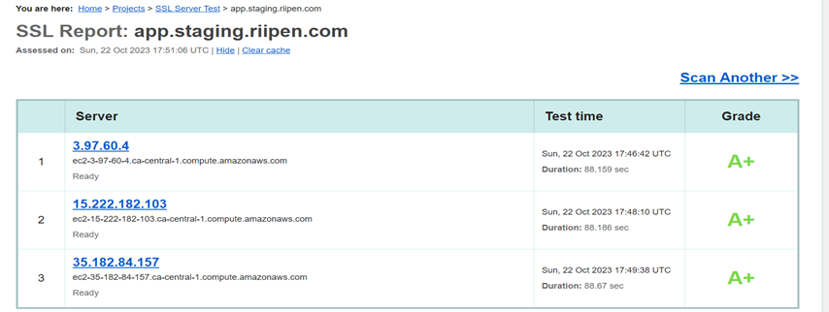

Fig 1. Capturing load-balancer details

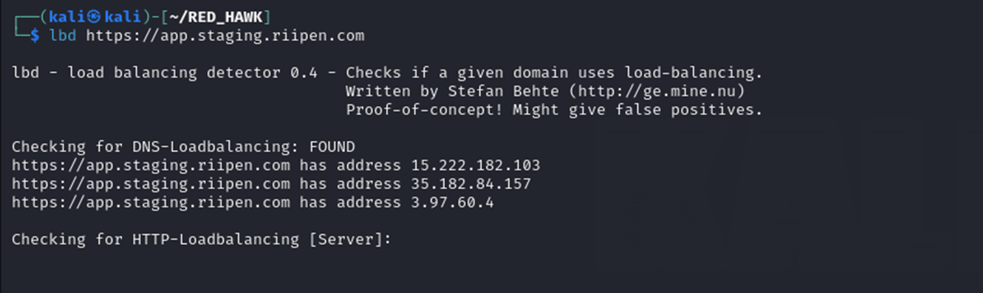

Fig 2. Capturing reverse proxy

**Result:** This ensures that the website can handle massive requests and will be challenging to bring down via DOS attacks.

**Tech Stack:** This helps us understand what technology the application is based on, what OS it's using to host, and the various versions of the software being deployed at the application end.

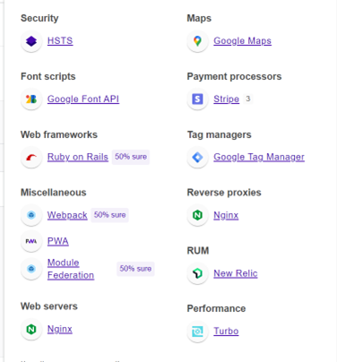

Fig 3.Technical stack of the application

**Result**: Based on the data gathered, software and OS versions are up-to-date. The web is safe from any software outdated vulnerability attack.

**Internal IP exposure:** The disclosure of internal IP addresses on public-facing web applications is a security risk that can provide attackers with valuable information about an organization's internal network and systems. Exposed internal IPs enable attackers to gather details about the network architecture, which can then inform exploitation attempts and other targeted attacks. Internal systems and services not intended to be public should have their IP addresses hidden. Proper network segmentation, access controls, and avoiding IP address leaks in web content are key to mitigating this vulnerability.

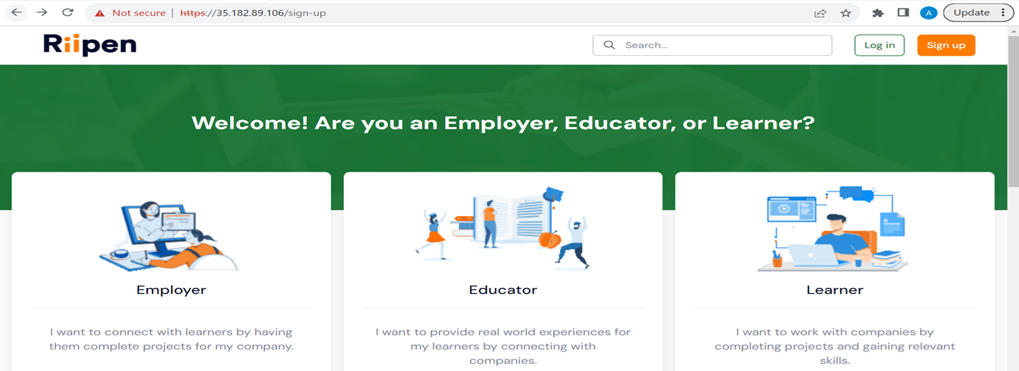

Fig 4.

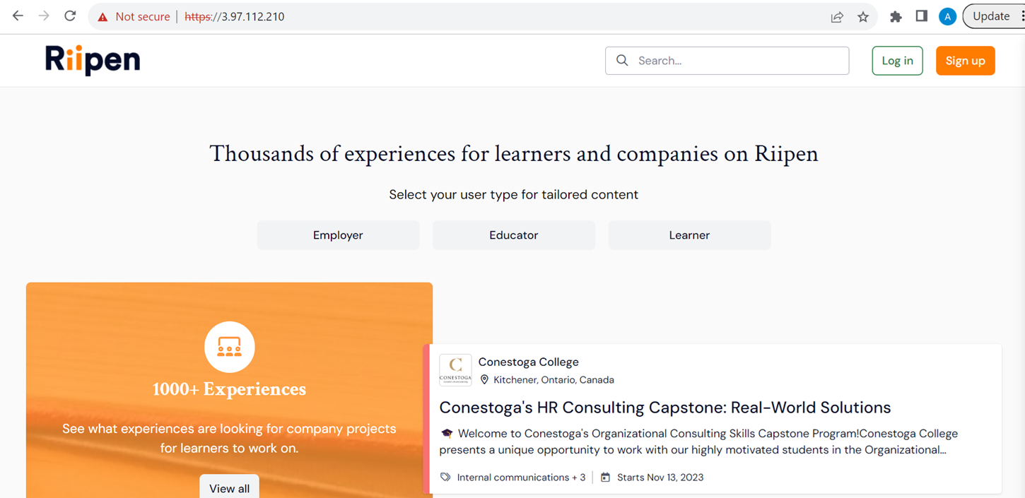

Fig 5. No HTTPS , only HTTP

**Result**: This is a huge vulnerability, as attackers can easily penetrate internal networks. We have informed the customer, and they are working on it now.